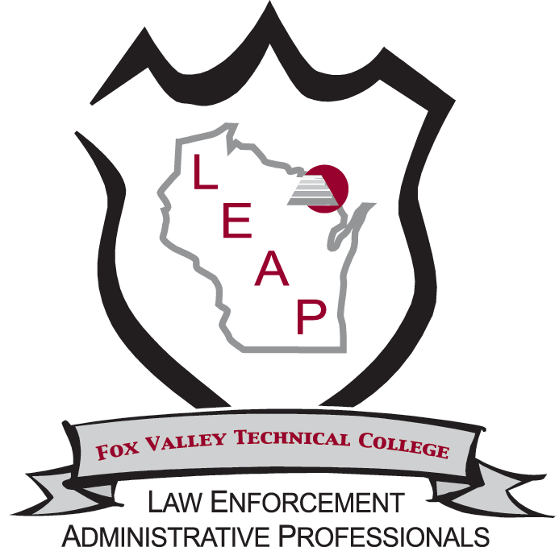
Annual LEAP Award Nomination Form
WI Law Enforcement Administrative Professionals Annual Training Conference
June 22 - 24, 2022 | Oshkosh, WI
Nominations are due May 6, 2022

Do you have an administrative professional working in your office who has shown exemplary community outreach efforts, volunteerism, or a significant work project? The LEAP award program provides a wonderful opportunity to recognize individuals who have truly made a difference in your community and department.

All nominees will be recognized in the program materials, during the conference, and on the LEAP website. Prior to the conference, we will notify the award recipient nominator, so they may participate in the awards ceremony. We will ask that this information be kept confidential until the June 24, 2022 award ceremony during the WI LEAP Conference.

Nominee Name
Title
Agency
Address
City/State/Zip
Phone
Email
Years with Agency
Nominated by
Title
Agency/Organization
Address
City/State/Zip
Email
Best way to contact you

On the following page, please tell us about your nominee’s accomplishments.
Please include as much detail as you can about their unique characteristics, special programs, and contributions beyond their normal duties that would help us select this year’s award recipient. Nominations will be accepted by administrators, co-workers, administrative professionals, community leaders, or citizens.

Tell us about your nominee:

Submit your completed nomination form via email by Friday May 6, 2022 | Email  heimann@fvtc.edu

