CTAS Orientation Registration Process
Starting the registration process
- Visit National Criminal Justice Training Center Web site, www.NCJTC.org/CTAS, click registration link here.
- Click Register
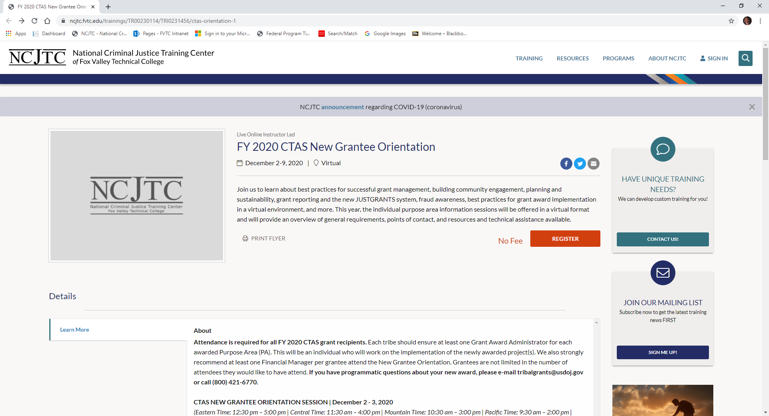

Complete Sign In information
- If you have attended previous training with the National Criminal Justice Training Center:
  - Enter ID (this will be your FVTC 7-digit ID number)
    - Forgot ID?
      - Click on Forgot ID?
        - See instructions for find account.

  - Enter password
    - Forgot your password?
      - Click on Forgot Password?
        - Enter ID
          - Confirm Account and click on continue
            - Select method to have security code sent to
              - Enter 4-digit code and click Continue
                - Follow prompts to reset password.
  - Click Sign In

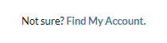
Not sure if you have an account:
- Select Find My Account
  - Enter First Name, Last Name, and Birth Month and Year (optional)
Not finding your account?
- Try searching with long and short versions of your first name (for example: use both Robert and Bob).
- Search with previous last names.
- Try adding in your birth month and year to limit results.
- If you signed a “Prevent Disclosure of Directory Information Form” this will keep your account from appearing in the list.
- If none of these options help, then please call the Help desk at 920-735-5644 or use our Contact Form.

Found your account:
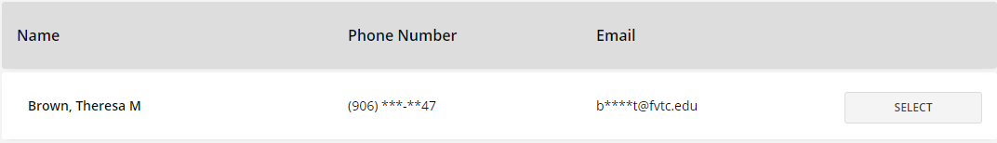

- Click Select
  - Your FVTC ID and other information will be displayed.
    - Select SIGN IN and continue with Complete Sign in Information instructions. (Page 1)
Don’t have an Account?
- Select Create Account
  - Fill out all tabs and fields
    - Click Next
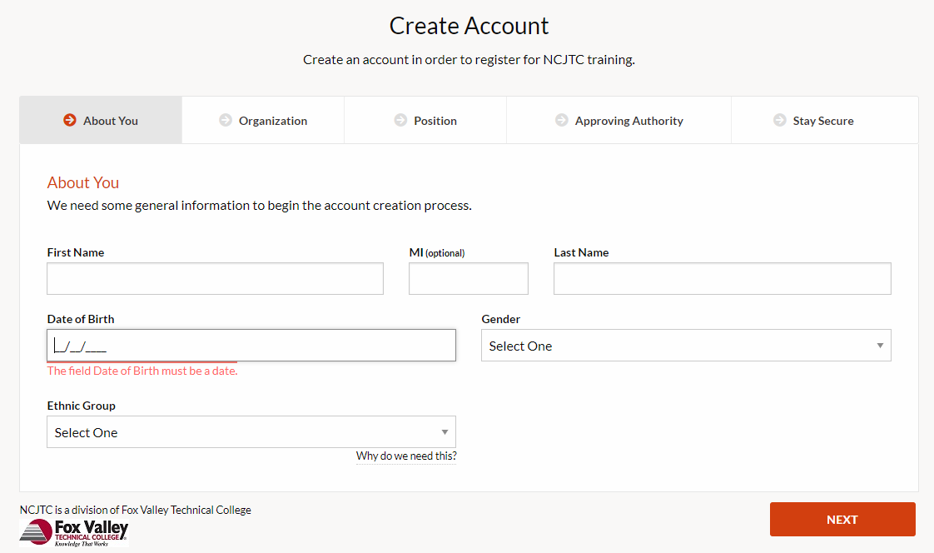

Organization can’t be found
- Select Help, my organization is not listed
  - Fill out Organization Name (name of department you work in), Type, Country, Address (must be street address), City, State, Postal Code, and Organization Phone.
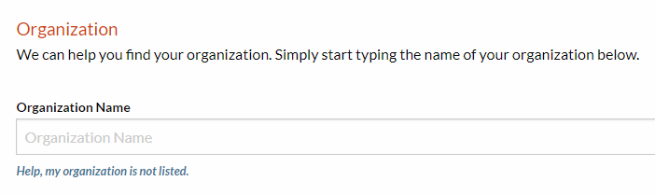

Completed sign-in/created an account!
- Once you have signed-in/created an account you will complete the registration process.
  - Click Get Started to finish registration
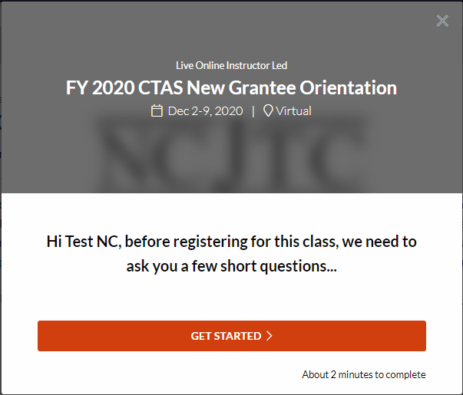

  - Choose your organization
      - Click next
  - A class roster may be generated and distributed to course participants.
    - Select Yes or No
      - Click next
  - For state reporting purposes, select you’re your disability status
    - Select Yes or No
      - Click next
  - From the list, select which most closely describes your professional discipline
    - Once you’ve made your selection, click next
  - Which Tribe are you representing?
    - Fill in and click next
  - Will you be attending the Orientation as the Financial Manager or Grant Award Administrator?
    - Check all that apply
      - Click next
  - Which purpose area(s) will you be representing?
    - Check all that apply
      - Click next
  - Have you attended any prior CTAS Orientations?
    - Select Yes or No
      - Click next
Click CONFIRM
Congratulations! You’re registered! An email confirmation will be sent shortly.
